

Engenharia de Software

Docente: Vasco Amaral

JabRef

Relatório G21

Trabalho realizado pelo grupo:

Bernardo Reis 57802

Martim Gouveia 57482

Pedro Caldeirão 57945

Pedro Lourenço 57577

Pedro Perdigão 58165

**User Stories e User Cases – Journal**

**Geral – Tab, use case**

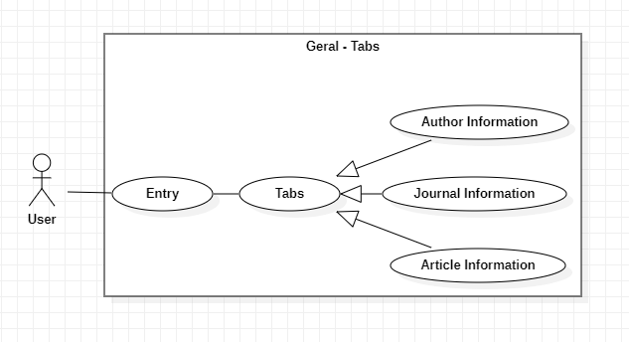

**Description**

Use case diagram description for use case Geral Tabs

This description is useful for all the use cases that implement this one, preventing repetitions.

User case: Entry

ID: 1

Description: The use chooses what entry/article he wants to check

Main actor: User

Secondary actors: None

Use case: Tabs

ID: 2

Description: All the tabs that entry/article has that the user can choose

Main actor: User

Secondary actors: None

Use case: Tabs --- Author Information

ID: 3

Description: Tab that shows all the information of the author

Main actor: User

Secondary actors: None

Use case: Tabs --- Journal information

ID: 4

Description: Tab that shows all the information of the journal

Main actor: User

Secondary actors: None

Use case: Tabs --- Article Information

ID: 5

Description: Tab that shows all the information of the article

Main actor: User

Secondary actors: None

**Query Results – Geral, use case**

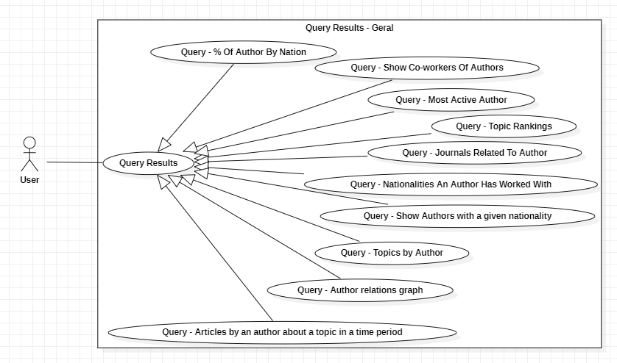

**Description**

Use case diagram description for use case Geral

This description is useful for all the Query use cases, preventing repetitions.

User case: Query Results

ID: 1

Description: Button that show all queries.

Main actor: User

Secondary actors: None

Use case: Query Results --- Query - % Of Author by Nation

ID: 2

Description: Button when clicked shows the percentage of the authors ordered by nationality

Main actor: User

Secondary actors: None

Use case: Query Results --- Query - Show Co-workers of Authors

ID: 3

Description: Button when clicked shows the co-workers of a given author

Main actor: User

Secondary actors: None

Use case: Query Results --- Query - Most Active Author

ID: 4

Description: Button when clicked shows the author with most publications

Main actor: User

Secondary actors: None

Use case: Query Results --- Query - Topic Rankings

ID: 5

Description: Button when clicked shows the topics of all articles ordered by the most used

Main actor: User

Secondary actors: None

Use case: Query Results --- Query - Journals Related to Author

ID: 6

Description: Button when clicked shows the journals a given author has published

Main actor: User

Secondary actors: None

Use case: Query Results --- Query - Nationalities an Author Has Worked With

ID: 7

Description: Button when clicked shows nationalities that a given actor has worked with

Main actor: User

Secondary actors: None

Use case: Query Results --- Query - Author relations

ID: 8

Description: Button when clicked shows the relations between the authors

Main actor: User

Secondary actors: None

Use case: Query Results --- Query - Topics by author

ID: 9

Description: Button when clicked shows all the topics that a given author has write about

Main actor: User

Secondary actors: None

Use case: Query Results --- Query - Show authors with a given nationality

ID: 10

Description: Button when clicked shows all the authors of a given nationality

Main actor: User

Secondary actors: None

Use case: Query Results --- Articles by an author about a topic in a time period

ID: 11

Description: Button when clicked shows the articles written by a giving author, about a giving topic in a given time period

Main actor: User

Secondary actors: None

**User Story 1**

User story: “As a user I want to see the top authors with more articles on a journal in order to check the most prestigious authors of the journal.”

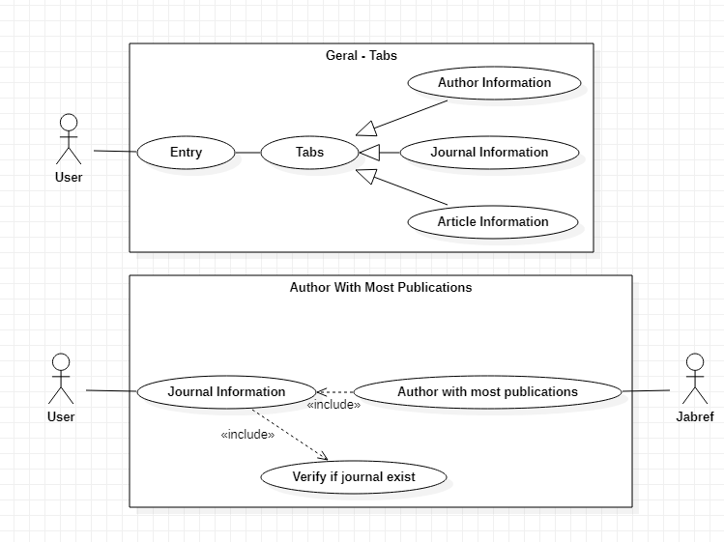Use case:

**Description:**

Use case diagram description for use case Author with More Publications

The description about the Geral tabs use case is already done in another file, preventing repetitions.

* + Use case: Journal Information

ID: 1

Description: Tab that shows all the information of the journal

Main actor: User

Secondary actors: None

* + Use case: Verify if journal exist

ID: 2

Description: Verify if the given journal exists

Main actor: User

Secondary actors: None

* + Use case: Author with more publications

ID: 3

Description: Textbox where will be displayed the name of the author with more publications

Main actor: User

Secondary actors: Jabref

**User Story 2**

* User story: “As a user I want to check the rankings of the authors of a certain journal by nationality in order to collect data for my research about this journal.”
* 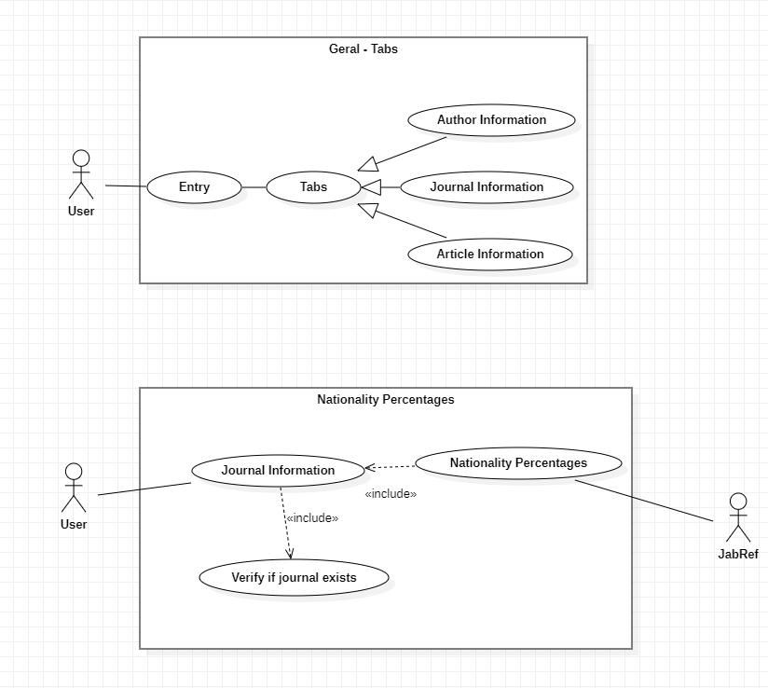Use case:
* Use case description:

Geral use cases were described in another file

* + Use case: Journal Information

ID: 0

Description: Tab that will show us some informations

Main actors: User

Secondary actors: None

* + Use case: Verify if journal exist

ID: 1

Description: Verify if the given journal exists

Main actor: User

Secondary actors: None

* + Use case: Nationality Percentages

ID: 2

Description: JabRef shows the percentage of nationalities of the author that exists in the journal

Main actor: User

Secondary actors: Jabref

**User Story 3**

* User story: “As a user I want to see the rankings of the most written topics because I want to see what topic the journal focuses on.”
* 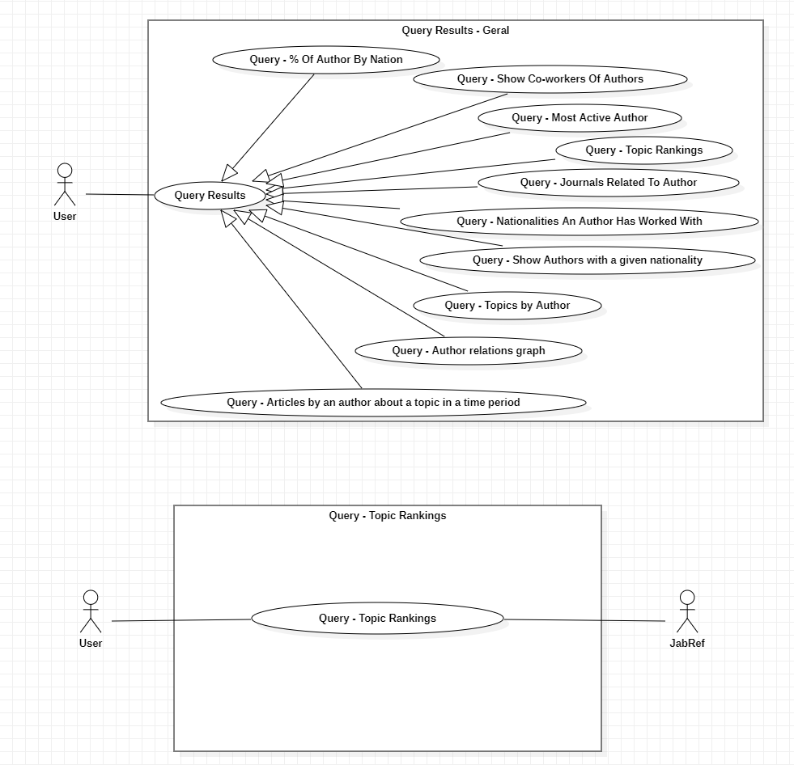Use case:
* Use case description:

Geral use cases were described in another file

* + Use case: Get the topic rankings in the database

ID: 0

Description: Button that when is clicked shows a pop-up of the topic rankings in the database by order of the must use.

Main actors: User

Secondary actors: None

**User Story 4**

* User story: “As a user I want to see in a certain time period there were more articles written because I want to see at what time the journal articles are inserted.”
* 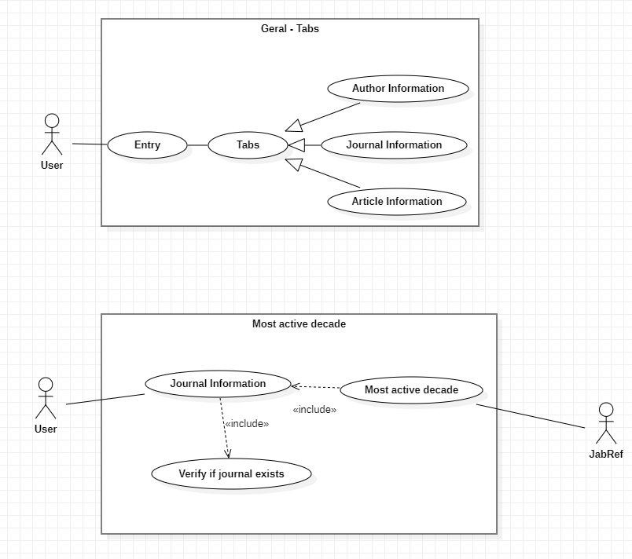Use case:
* Use case description:

Geral use cases were described in another file

* + Use case: Journal Information

ID: 0

Description: Tab that will show us some informations

Main actors: User

Secondary actors: None

* + Use case: Verify if journal exists

ID: 1

Description: Verify if journal exists. If not, the Tab do not show up

Main actors: User

Secondary actors: None

* + Use case: Most active decade

ID: 2

Description: JabRef shows decade that the journal is inserted in, that is, see which decade has the most articles in this journal

Main actors: User

Secondary actors: JabRef

**User Story 5**

* User story: “As a user I want to see the top best articles in the journal to know how important and well-built this journal is based on the amount of good articles.”
* Use case:

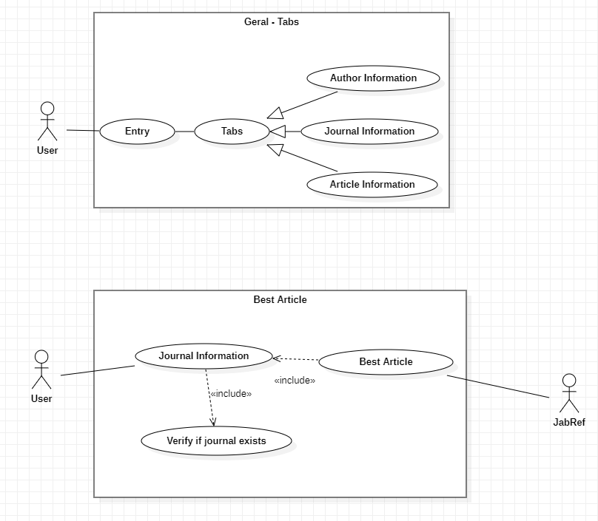

* Use case description:

Geral use cases were described in another file

* + Use case: Journal Information

ID: 0

Description: Tab that will show us some informations

Main actors: User

Secondary actors: None

* + Use case: Verify if journal exists

ID: 1

Description: Verify if journal exists. If not, the Tab do not show up

Main actors: User

Secondary actors: None

* + Use case: Best Article

ID: 2

Description: JabRef shows the best article to the user

Main actors: User

Secondary actors: JabRef

**User Stories e User Cases – Authors**

**User Story 1**

* User story: “As a user I want to list the rankings of authors by nationality because I want to see the percentages of authors by nationalities in the jabref database.”
* 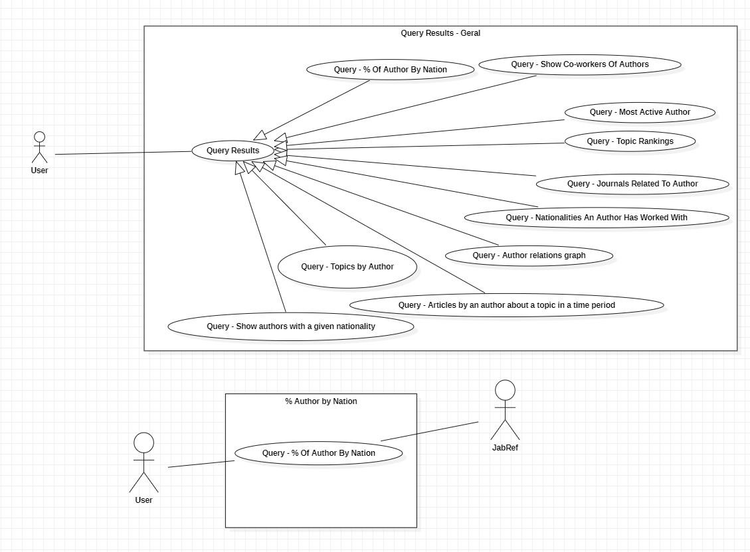Use case:
* Use case description:

Geral use cases were described in another file

* + Use case: Get the nationalities percentages in the database

ID: 0

Description: Button that when is clicked shows a pop-up of the nationalities percentages of the database

Main actors: User

Secondary actors: JabRef

**User Story 2**

* User story: “As a user I want to list the articles that the author has published about a certain topic during a time period because I want to see the evolution of the articles.”
* 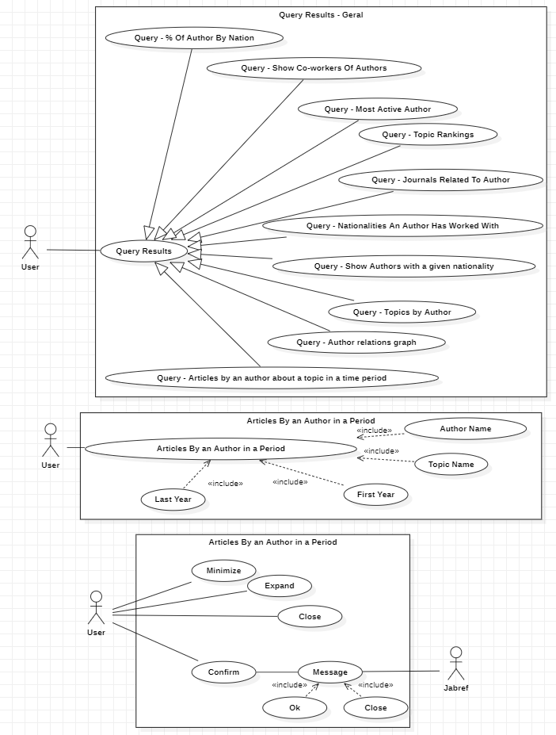Use case:
* Use case description:

Use case diagram description for use case Articles By an Author in a Period. The description of the "Query Results - Geral" use case is done in other file in order to preventing repetitions.

* + Use case: Query - Articles

ID: 0

Description: Button that when is clicked shows a pop-up of all the Articles By a given Author in a Period of time

Main actors: User

Secondary actors: None

* + Use case: Query - Author Name

ID: 1

Description: When the user uses the use case (ID0) a new window is open in order to give the name of the author

Main actor: User

Secondary actors: None

* + Use case: Query - Topic Name

ID: 2

Description: When the user uses the use case (ID0) a new window is open in order to give the name of the topic

Main actor: User

Secondary actors: None

* + Use case: Query - First Year

ID: 3

Description: When the user uses the use case (ID0) a new window is open in order to give the first year

Main actor: User

Secondary actors: None

* + Use case: Query - Last Year

ID: 4

Description: When the user uses the use case (ID0) a new window is open in order to give the last year

Main actor: User

Secondary actors: None

* + Use case: Articles By an Author in a Period --- Minimize

ID: 5

Description: Button when clicked minimizes the window

Main actor: User

Secondary actors: None

* + Use case: Articles By an Author in a Period --- Expand

ID: 6

Description: Button when clicked expands the window

Main actor: User

Secondary actors: None

* + Use case: Articles By an Author in a Period --- Close

ID: 7

Description: Button when clicked closes the window

Main actor: User

Secondary actors: None

* + Use case: Articles By an Author in a Period --- Confirm

ID: 9

Description: Button when clicked shows confirms the name of the author and open a new window with the answer

Main actor: User

Secondary actors: None

* + Use case: Confirm --- Message

ID: 10

Description: New window that give the answer when the user used the use case (ID9)

Main actor: User

Secondary actors: Jabref

* + Use case: Confirm --- Ok

ID: 11

Description: Button that confirm and close the window with the answer

Main actor: User

Secondary actors: None

* + Use case: Confirm --- Close

ID: 12

Description: Button that close the window with the answer

Main actor: User

Secondary actors: None

**User Story 3**

* User story: “As a user I want to list the editors a specific author has worked with because I'm writing a biography about him.”
* 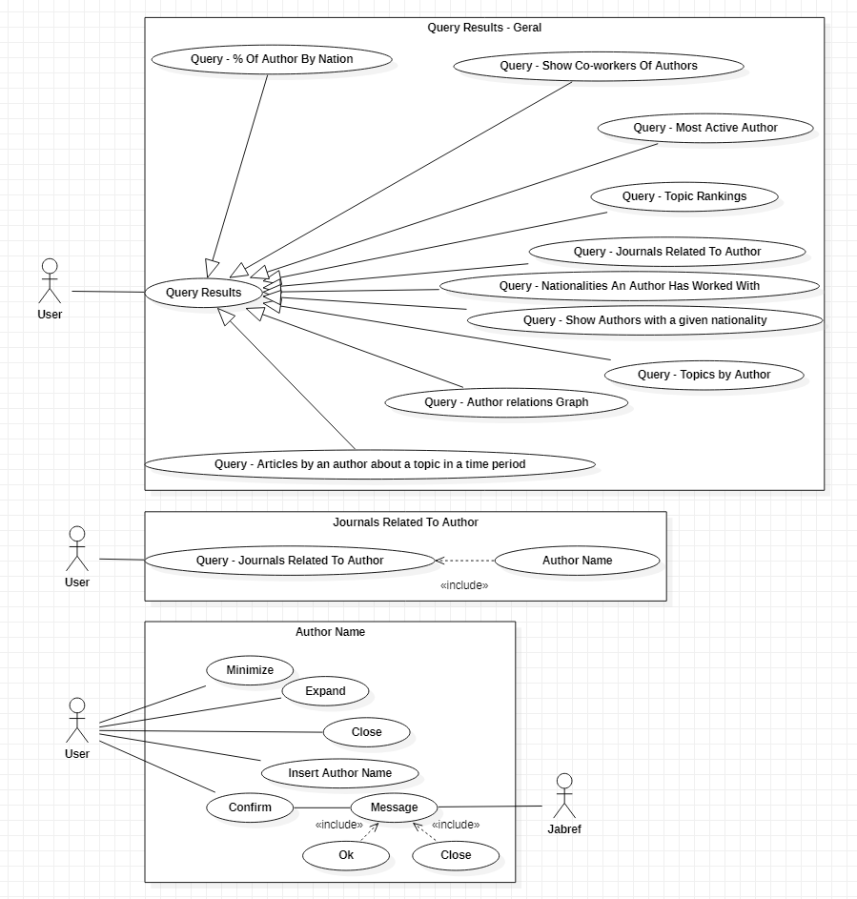Use case:
* Use case description:

Use case diagram description for use case Journals Related to Author. The description of the "Query Results - Geral" use case is done in other file in order to preventing repetitions.

* + Use case: Query - Journal Related To Author

ID: 0

Description: Button that when is clicked shows a pop-up of all the journals related to a given author

Main actors: User

Secondary actors: None

* + Use case: Query - Author Name

ID: 1

Description: When the user uses the use case (ID0) a new window is open in order to give the name of the author

Main actor: User

Secondary actors: None

* + Use case: Author Name --- Minimize

ID: 2

Description: Button when clicked minimizes the window

Main actor: User

Secondary actors: None

* + Use case: Author Name --- Expand

ID: 3

Description: Button when clicked expands the window

Main actor: User

Secondary actors: None

* + Use case: Author Name --- Close

ID: 4

Description: Button when clicked closes the window

Main actor: User

Secondary actors: None

* + Use case: Author Name --- Insert Author name

ID: 5

Description: Textbox where the user can write the name of the author

Main actor: User

Secondary actors: None

* + Use case: Author Name --- Confirm

ID: 6

Description: Button when clicked shows confirms the name of the author and open a new window with the answer

Main actor: User

Secondary actors: None

* + Use case: Confirm --- Message

ID: 7

Description: New window that give the answer when the user used the use case (ID6)

Main actor: User

Secondary actors: Jabref

* + Use case: Confirm --- Ok

ID: 8

Description: Button that confirm and close the window with the answer

Main actor: User

Secondary actors: None

* + Use case: Confirm --- Close

ID: 9

Description: Button that close the window with the answer

Main actor: User

Secondary actors: None

**User Story 4**

* User story: “As a user I want to see the authors that a certain author has worked with and the articles that they have in common because I want to see the authors work circle.”
* 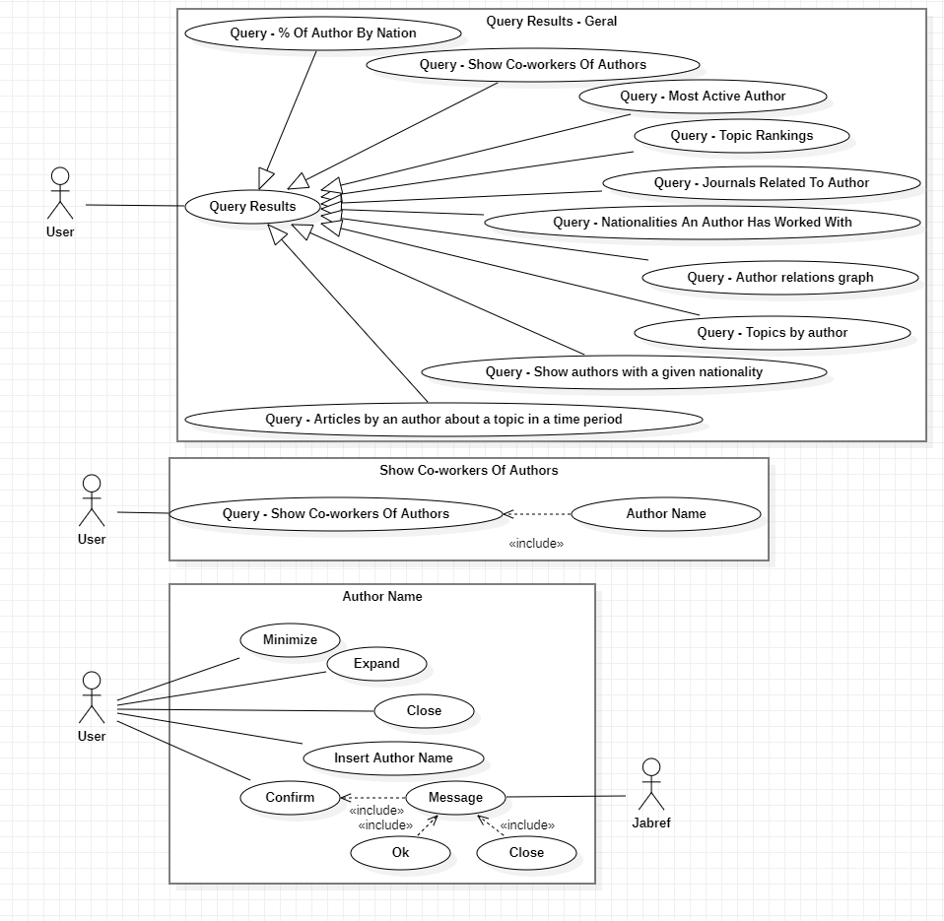Use case:
* Use case description:

Use case diagram description for use case co-workers. The description of the "Query Results - Geral" use case is done in other file to prevent repetitions.

* + User case: Query - Show Co-workers Of Authors

ID: 1

Description: Button when clicked shows the co-workers of a given author

Main actor: User

Secondary actors: None

* + Use case: Query - Show Co-workers Of Authors --- Author Name

ID: 2

Description: When the user uses the use case (ID1) a new window is open in order to give the name of the author

Main actor: User

Secondary actors: None

* + Use case: Author Name --- Minimize

ID: 3

Description: Button when clicked minimizes the window

Main actor: User

Secondary actors: None

* + Use case: Author Name --- Expand

ID: 4

Description: Button when clicked expands the window

Main actor: User

Secondary actors: None

* + Use case: Author Name --- Close

ID: 5

Description: Button when clicked closes the window

Main actor: User

Secondary actors: None

* + Use case: Author Name --- Insert Author name

ID: 6

Description: Textbox where the user can write the name of the author

Main actor: User

Secondary actors: None

* + Use case: Author Name --- Confirm

ID: 7

Description: Button when clicked shows confirms the name of the author and open a new window with the answer

Main actor: User

Secondary actors: None

* + Use case: Confirm --- Message

ID: 8

Description: New window that give the answer when the user used the use case (ID7)

Main actor: User

Secondary actors: Jabref

* + Use case: Confirm --- Ok

ID: 9

Description: Button that confirm and close the window with the answer

Main actor: User

Secondary actors: None

* + Use case: Confirm --- Close

ID: 10

Description: Button that close the window with the answer

Main actor: User

Secondary actors: None

**User Story 5**

* User story: “As a user I want to list the authors by number of articles to know who the most active author is.”
* 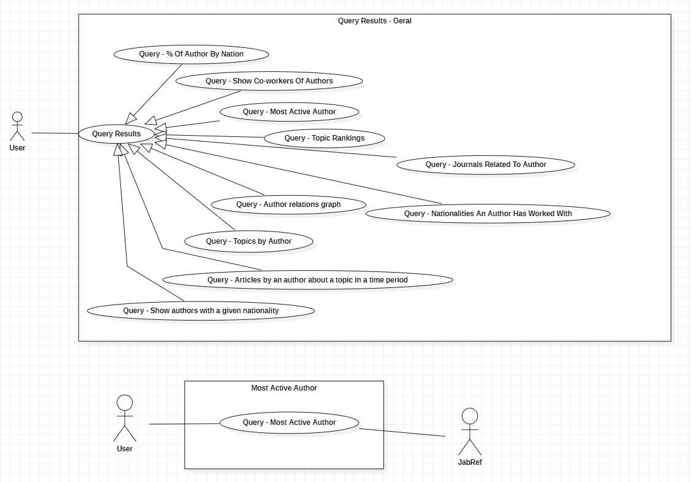Use case:
* Use case description:

Geral use cases were described in another file

* + Use case: Get the most active author in the database

ID: 0

Description: Button that when is clicked shows a pop-up of the author with the most articles published in the database

Main actors: User

Secondary actors: JabRef

**User Story 6**

* User story: “As a user I want to list the topics that the authors worked about because I want to know the author preferences.”
* Use case:

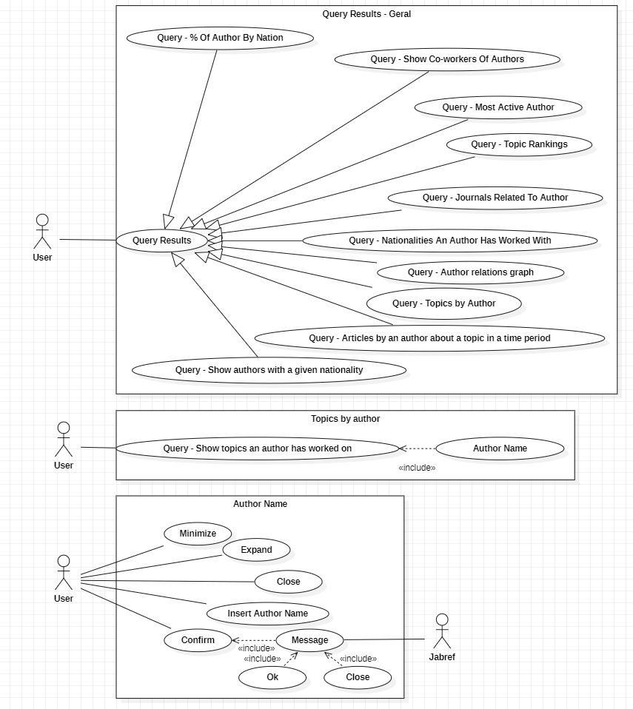

* Use case description:

Use case diagram description for use case show the topics a user has worked on. The description of the "Query Results - Geral" use case is done in other file in order to preventing repetitions.

* + User case: Query - Show topics and author has worked on

ID: 1

Description: Button when clicked shows the topics a user has worked on

Main actor: User

Secondary actors: None

* + Use case: Query - Show topics and author has worked on --- Author Name

ID: 2

Description: When the user uses the use case (ID1) a new window is open in order to give the name of the author

Main actor: User

Secondary actors: None

* + Use case: Author Name --- Minimize

ID: 3

Description: Button when clicked minimizes the window

Main actor: User

Secondary actors: None

* + Use case: Author Name --- Expand

ID: 4

Description: Button when clicked expands the window

Main actor: User

Secondary actors: None

* + Use case: Author Name --- Close

ID: 5

Description: Button when clicked closes the window

Main actor: User

Secondary actors: None

* + Use case: Author Name --- Insert Author name

ID: 6

Description: Textbox where the user can write the name of the author

Main actor: User

Secondary actors: None

* + Use case: Author Name --- Confirm

ID: 7

Description: Button when clicked shows confirms the name of the author and open a new window with the answer

Main actor: User

Secondary actors: None

* + Use case: Confirm --- Message

ID: 8

Description: New window that give the answer when the user used the use case (ID7)

Main actor: User

Secondary actors: Jabref

* + Use case: Confirm --- Ok

ID: 9

Description: Button that confirm and close the window with the answer

Main actor: User

Secondary actors: None

* + Use case: Confirm --- Close

ID: 10

Description: Button that close the window with the answer

Main actor: User

Secondary actors: None

**User Story 7**

* User story: “As a user I want to see with how many different nationalities the author has collaborated with because I want to know how well known the author is internationally.”
* 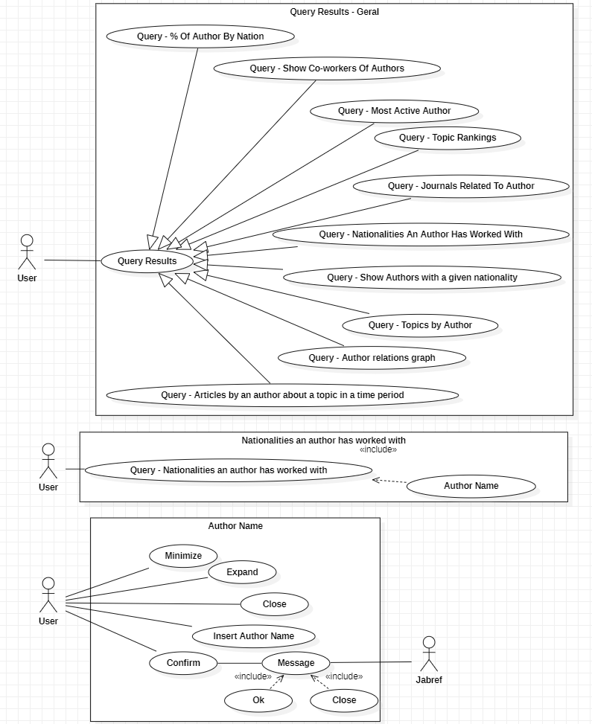Use case:
* Use case description:

Use case diagram description for use case Nationalities an author has worked with. The description of the "Query Results - Geral" use case is done in other file in order to preventing repetitions.

* + Use case: Query - Nationalities an author has worked with

ID: 0

Description: Button that when is clicked shows a pop-up of all the Nationalities a given author has worked with

Main actors: User

Secondary actors: None

* + Use case: Query - Author Name

ID: 1

Description: When the user uses the use case (ID0) a new window is open in order to give the name of the author

Main actor: User

Secondary actors: None

* + Use case: Author Name --- Minimize

ID: 2

Description: Button when clicked minimizes the window

Main actor: User

Secondary actors: None

Use case: Author Name --- Expand

ID: 3

Description: Button when clicked expands the window

Main actor: User

Secondary actors: None

* + Use case: Author Name --- Close

ID: 4

Description: Button when clicked closes the window

Main actor: User

Secondary actors: None

* + Use case: Author Name --- Insert Author name

ID: 5

Description: Textbox where the user can write the name of the author

Main actor: User

Secondary actors: None

* + Use case: Author Name --- Confirm

ID: 6

Description: Button when clicked shows confirms the name of the author and open a new window with the answer

Main actor: User

Secondary actors: None

* + Use case: Confirm --- Message

ID: 7

Description: New window that give the answer when the user used the use case (ID6)

Main actor: User

Secondary actors: Jabref

* + Use case: Confirm --- Ok

ID: 8

Description: Button that confirm and close the window with the answer

Main actor: User

Secondary actors: None

Use case: Confirm --- Close

ID: 9

Description: Button that close the window with the answer

Main actor: User

Secondary actors: None

**User Story 8**

* User story: “As a user I want to list all the authors that have a certain nationality because I want to know the authors of this
* Nationality.”
* 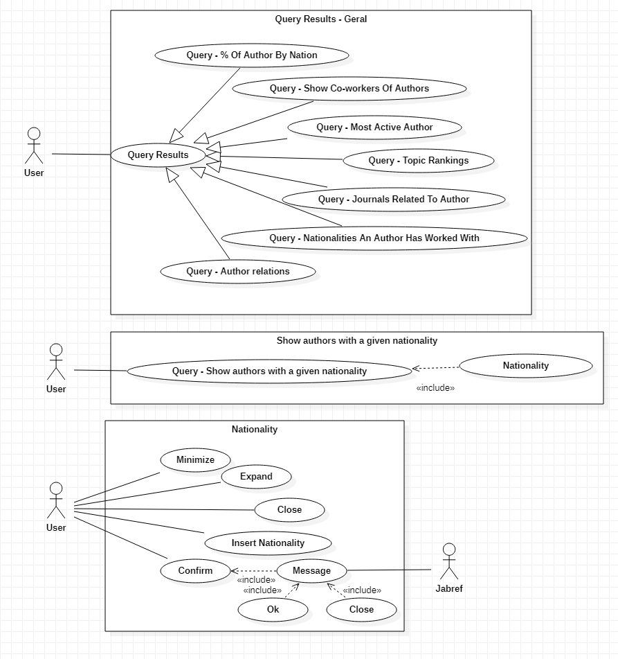Use case:
* Use case description:

Use case diagram description for use case authors nationality.

The description of the "Query Results - Geral" use case is done in other file to prevent repetitions.

* + Use case: Query - Show authors with a given nationality

ID: 1

Description: Button when clicked shows the co-workers of a given author

Main actor: User

Secondary actors: None

* + Use case: Query - Show authors with a given

nationality --- Nationality

ID: 2

Description: When the user uses the use case (ID1) a new window is open in order to give the nationalities of the authors

Main actor: User

Secondary actors: None

* + Use case: Nationality --- Minimize

ID: 3

Description: Button when clicked minimizes the window

Main actor: User

Secondary actors: None

* + Use case: Nationality --- Expand

ID: 4

Description: Button when clicked expands the window

Main actor: User

Secondary actors: None

* + Use case: Nationality --- Close

ID: 5

Description: Button when clicked closes the window

Main actor: User

Secondary actors: None

Use case: Nationality --- Insert Nationality

ID: 6

Description: Textbox where the user can write the name of the author

Main actor: User

Secondary actors: None

* + Use case: Nationality --- Confirm

ID: 7

Description: Button when clicked shows confirms the name of the author and open a new window with the answer

Main actor: User

Secondary actors: None

* + Use case: Confirm --- Message

ID: 8

Description: New window that give the answer when the user used the use case (ID7)

Main actor: User

Secondary actors: Jabref

Use case: Confirm --- Ok

ID: 9

Description: Button that confirm and close the window with the answer

Main actor: User

Secondary actors: None

* + Use case: Confirm --- Close

ID: 10

Description: Button that close the window with the answer

Main actor: User

Secondary actors: None

**User Story 9**

* User story: “As a user I want to see a graph displaying all the authors that have worked with each other with different node colours depending on the author's nationality because I want to know the relations of the authors with authors of other nationalities.”
* Use case:

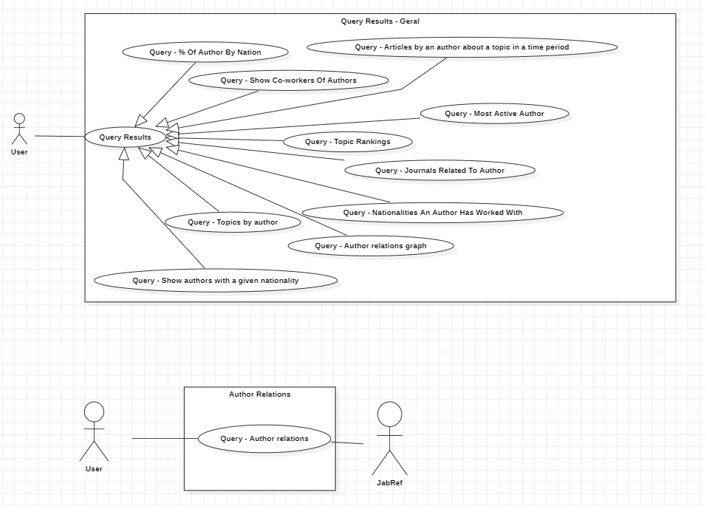

* Use case description:

Geral use cases were described in another file

* + Use case: Get the authors that every author has worked with in the database

ID: 0

Description: Button that when is clicked shows a pop-up of a graph-like structure representing all the relations of every single author in the database

Main actors: User

Secondary actors: JabRef

**YouTube link video**